LESSON TITLE: Patterns and Reasoning

Grade Level(s): 1st Subject(s): Math Lesson Length: 1 day: 50 minutes
Prepared by: Pamela Rodriguez, Stephanie Pepper, Candace Deonarine

Overview: [What is the overall purpose of this lesson?]
The students will create their own patterns, demonstrating sequences of shapes. They will decide what shapes go where and critically think of these repeating patterns as they work online , individually and in groups.
Standards: [What standards/benchmarks are you students going to achieve with this lesson? Use Florida Sunshine State Standards or Common Core Standards AND NETS-S Standards.]
- MA.1.A.4.1: Extend repeating and growing patterns, fill in missing terms, and justify reasoning.
- NETS-S 1a) Creativity and Innovation: Apply existing knowledge to generate new ideas, products, or processes.
Learning Objective: [What will your students be able to do when they finish this lesson or unit? Be sure to use action verbs and to include measurable behavioral outcome(s).]
Students will recognize patterns and organize sequences of shapes. They will form reasoning for missing terms and be able to justify why a certain shape belongs in a sequence.
Materials/Resources needed: [What materials and resources do you need for this lesson?]
Computers/ laptops for each student, teacher computer, Internet access and Internet browsers for everyone. Also, use the SmartBoard for the online activity. The Gathering Supplies worksheet requires glue and scissors, and a pencil.
Introduction: [How will you introduce your lesson?]
Teacher accesses online game called “Who’s missing,” to be completed with the students as a whole group, using the SmartBoard. Point out the repeating patterns displayed in the game; for example, mention how the colors/variables are sequenced. This activity is an interactive website where the students will create patterns using the patterning method (i.e. “A-B” and “A-B-C”), as well as working with numbers and letters.
Lesson Activities: [Itemize the details of your lesson - be complete and detailed.]
(10 mintues) The introductory web-based game that describes patterning.
(10 minutes) Discuss with the students the concept of patterning, how shapes show repeating factors, and explore patterning within the classroom. (I.e. patterns on posters, clothing). Also, have the students arrange themselves in a male/ female pattern, while the teacher oversees.
(15 minutes) Students will complete the Gathering Supplies worksheet (found in Mailbox.com, copy attached). This worksheet allows students to complete patterns using fine motor skills and hand- eye coordination.
(15 minutes) Students will access the Crickweb website to individually play the “String of Beads” game. (Once they enter the website, direct them to scroll down the page and find the game). This game allows them to use knowledge gained from this lesson to recreate patterns and practice their new found ideas.
Strategies - ESE/ESOL: [How will you support students who have special needs?]
This lesson is well- suited for multicultural students and those who do not speak English well. It also incorporates many visual learning techniques such as the online activities and the in- class examples. Although there are some discussions included, there are visual aids to help guide the students.
Strategies - Integrating Technologies: [What technologies did you choose to use for this lesson?]
This lesson integrates technology through SmartBoard and web- based activities; each meeting the Common Core and NETS-S standards.
Evaluation/Critique of Educational Software/Web-based Resource: [Describe your reasoning in selecting the software/ web-based resource you used for this lesson - why was it selected? What makes it enhance the lesson and make it effective?]
SmartBoard is a helpful tool to use so the students can view the lesson as it is being taught. It especially keeps the attention of visual and auditory learners, as well as gives everyone a chance to interact during the lesson. The web- based activities compliments the needs of every type of learner (visual, auditory, and kinesthetic). These games and activities stimulate the mind and engage the students in their learning.
Summary: [How will you summarize your lesson?]
Student will create patterns using both hands- on constructive materials as well as technology to practice the concept of patterning.They will have learned about extended repeating and missing terms, based on colors, shapes, numbers, etc.
Assessment - Type: [How will you assess your students to be sure they have met your learning objective(s)?]
The rubric, attached, specifies how the students will be evaluated. Content areas include participation, and group and individual learning settings.
Educational Theorist: [Identify and explain to which learning theory/theorists your lesson subscribes.]
Cognitive is the theory of thinking that uses memory, knowledge and problem solving to understand and learn concepts. This lesson incorporates cognitive thinking through recognizing and memorizing patterning. Based on their existing knowledge and what they have learned in the class, students will have an opportunity to create their own patterns throughout the lesson.

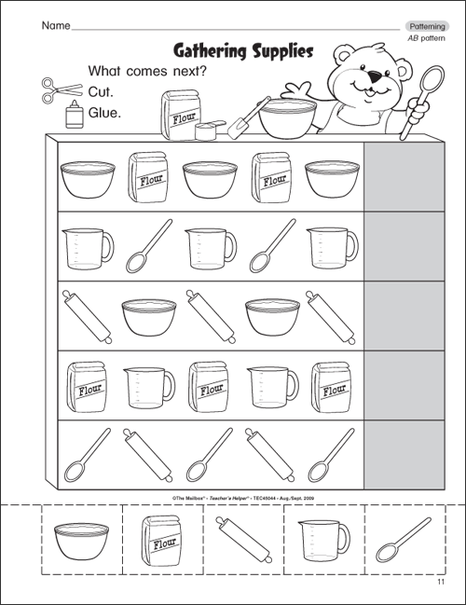

Lesson Evaluation

 | Lousy  1 point | Needs Improvement  2 points | Meets Expectations  3 points | Exceptional  4 points
Introduction (“Who’s Missing”) | Students do not participate in the online activity and do not talk during group talk. They do not pay attention and they create distractions for everyone in the class. Also they do not make accurate patterns that coincide with the activity. | Students participate in the online activity but they are not involved in group talk. They do not pay attention but they are not creating distractions. Students create accurate patterns that coincide with the activity. | Students participate in the online game and are involved in group talk. They pay attention during the lesson but create some distractions. Students create accurate patterns that coincide with the activity. | Students participate in the online game as a whole class; they are involved in group talk. They pay attention during the lesson and do not create distractions. Students create accurate patterns coinciding with the activity.
Gathering Supplies Worksheet | Students do not stay on task and their worksheet is not completed within the time given. There is no name on the worksheet. Students did not cut and glue their assignment accurately; no hand- eye coordination or motor skills are present. | Students stay on task but do not complete the worksheet in the time provided. Their name is not on the worksheet but they display accurate hand- eye coordination and motor skills as they cut and glued their assignment. | Students stay on task and completes the worksheet, but their hand- eye coordination and motor skills are not shown accurately due to the way they cut and glued their finished assignment. The worksheet includes the name of the student. | Students stay on task and completes the worksheet within the time provided. The worksheet should have their name on it. Also, students should display accurate hand- eye coordination and motor skills as they cut and glue their finished assignment.
Discussion | Students do not participate in discussion during the class and do not share their thoughts and findings. They are not engaged in learning and pay no attention to the teacher and their classmates. They do not understand the material and can not use the concepts taught. | Students do not participate in discussion and do not share their thoughts and findings. They are engaged in learning and pay attention to the teacher and their classmates when directions are being given. Students understand the material but are not able to use the concepts being taught. | Students participate in discussion during the class, but do not share their findings when looking for patterns in the room. They are engaged in learning and pay attention to the teacher and their classmates when directions are given. Students understand the material and are able to use the concepts taught. | Students participate in discussion during the class; they share their thoughts and findings as they look for patterns in the room. They are engaged in learning and pay attention to the teacher and their classmates when directions are being given for activities. Students understand the material and are able to use the concepts taught.
Independent Game  (String of Beads) | Students do not show computer fluency; as they access the Internet, they do not follow the directions to find the game. They do not complete each level and are not on task. Their level of success is not seen in their independent work. Students do not understand the concepts. | Students show computer fluency and are able to access the Internet, but they do not follow directions to find the game. They do not complete each level or stay on task; they do not fully show their level of success on their game. Students show they understand the concepts. | Students show computer fluency as they access the Internet and follow directions to find the online game. They complete each level and stay on task; they show their level of success as they work on the game. Students do not understand the concepts. | Student show computer fluency as they access the Internet and follow directions to find the game. They complete each level and stay on task; they show their level of success as they work on the game independently. Students also show they understand the concepts.

Total Points: 4- 28 Total for Lesson Evaluation: ____
A 26- 28
B 25- 23
C 22- 20
D 19- 17
F 16- 0

